1. Batch Vs Online ML
Wednesday, March 17, 2021 5:30 PM
Day 4 - Batch ML Page 1
2. Batch/Offline ML
Wednesday, March 17, 2021 5:31 PM
Day 4 - Batch ML Page 2
3. The problem with Batch Learning
Wednesday, March 17, 2021 5:47 PM
Day 4 - Batch ML Page 3
4. Disadvantages of Batch ML
Wednesday, March 17, 2021 5:32 PM
1. Lots of Data
2. Hardware Limitation
3. Availability
Day 4 - Batch ML Page 4
1. Online Machine Learning
Thursday, March 18, 2021 4:27 PM
Day 5 - Online ML Page 5
2. When to use?
Thursday, March 18, 2021 4:33 PM
1. Where there is a concept drift
2. Cost Effective
3. Faster solution
Day 5 - Online ML Page 6
3. How to implement?
Thursday, March 18, 2021 4:28 PM
Day 5 - Online ML Page 7
4. Learning Rate
Thursday, March 18, 2021 4:28 PM
Day 5 - Online ML Page 8
5. Out of Core Learning
Thursday, March 18, 2021 4:28 PM
Day 5 - Online ML Page 9
6. Disadvantage
Thursday, March 18, 2021 4:29 PM
1. Tricky to use
2. Risky
Day 5 - Online ML Page 10
7. Batch Vs Online Learning
Thursday, March 18, 2021 4:29 PM
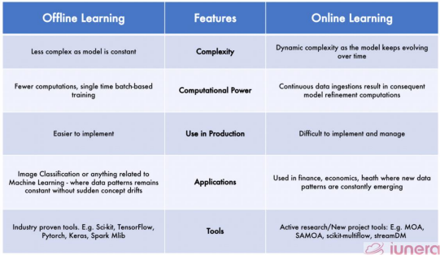
Image courtesy - https://www.iunera.com/kraken/fabric/simple-introduction-to-online-learning-in
machine-learning/
Day 5 - Online ML Page 11
1. Instance Vs Model Based Learning
Friday, March 19, 2021 4:05 PM
Day 6 - Instance Vs Model Based Learning Page 12
2. Instance Based
Friday, March 19, 2021 4:06 PM
Day 6 - Instance Vs Model Based Learning Page 13
3. Model Based
Friday, March 19, 2021 4:06 PM
Day 6 - Instance Vs Model Based Learning Page 14
4. Differences
Friday, March 19, 2021 4:06 PM
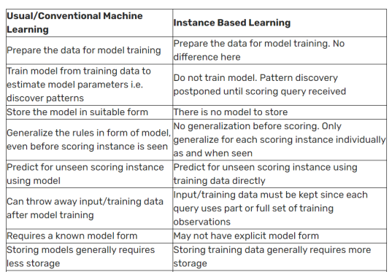 Day 6 - Instance Vs Model Based Learning Page 15
1. Data Collection
Saturday, March 20, 2021 5:59 PM
Day 7 - Challenges in ML Page 16
2. Insufficient Data/Labelled Data
Saturday, March 20, 2021 6:00 PM
Day 7 - Challenges in ML Page 17
3. Non Representative Data
Saturday, March 20, 2021 6:00 PM
Day 7 - Challenges in ML Page 18
4. Poor Quality Data
Saturday, March 20, 2021 6:00 PM
Day 7 - Challenges in ML Page 19
5. Irrelevant Features
Saturday, March 20, 2021 6:00 PM
Day 7 - Challenges in ML Page 20
6. Overfitting
Saturday, March 20, 2021 6:01 PM
Day 7 - Challenges in ML Page 21
7. Underfitting
Saturday, March 20, 2021 6:01 PM
Day 7 - Challenges in ML Page 22
8. Software Integration
Saturday, March 20, 2021 6:01 PM
Day 7 - Challenges in ML Page 23
9. Offline Learning/ Deployment
Saturday, March 20, 2021 6:01 PM
Day 7 - Challenges in ML Page 24
10. Cost Involved
Saturday, March 20, 2021 6:01 PM
Day 7 - Challenges in ML Page 25
1. Retail - Amazon/Big Bazaar
Monday, March 22, 2021 6:07 PM
 Day 8 - Applications of ML Page 26
2. Banking and Finance
Monday, March 22, 2021 6:07 PM
 Day 8 - Applications of ML Page 27
3. Transport - OLA
Monday, March 22, 2021 6:07 PM
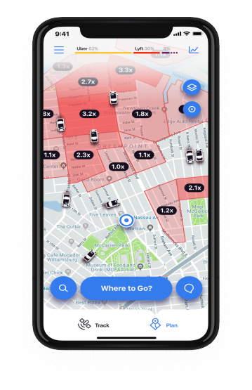 Day 8 - Applications of ML Page 28
4. Manufacturing - Tesla
Monday, March 22, 2021 6:08 PM
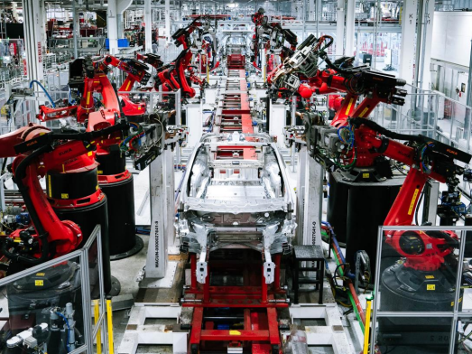 Day 8 - Applications of ML Page 29
5. Consumer Internet - Twitter
Monday, March 22, 2021 6:08 PM
 Day 8 - Applications of ML Page 30
Machine Learning Development Life Cycle(MLDLC/MLDC) Tuesday, March 23, 2021 12:09 PM
Day 9 - MLDLC Page 31
1. Frame the Problem
Tuesday, March 23, 2021 12:10 PM
Day 9 - MLDLC Page 32
2. Gathering Data
Tuesday, March 23, 2021 12:11 PM
Day 9 - MLDLC Page 33
3. Data Preprocessing
Tuesday, March 23, 2021 12:11 PM
Day 9 - MLDLC Page 34
4. Exploratory Data Analysis
Tuesday, March 23, 2021 12:11 PM
Day 9 - MLDLC Page 35
5. Feature Engineering and Selection
Tuesday, March 23, 2021 12:12 PM
Day 9 - MLDLC Page 36
6. Model Training,Evalation and Selection
Tuesday, March 23, 2021 12:12 PM
Day 9 - MLDLC Page 37
7. Model Deployment
Tuesday, March 23, 2021 12:13 PM
Day 9 - MLDLC Page 38
8. Testing
Tuesday, March 23, 2021 12:14 PM
Day 9 - MLDLC Page 39
9. Optimize
Tuesday, March 23, 2021 12:15 PM
Day 9 - MLDLC Page 40
1. Various Data Based Job Roles
Wednesday, March 24, 2021 1:25 PM
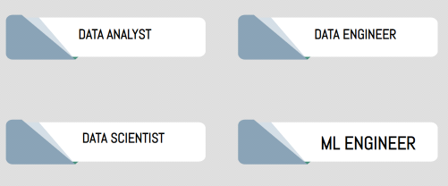 Day 10 - Job Roles Page 41
1. Data Engineer Wednesday, March 24, 2021 1:25 PM
Job Roles
Skills Required
○ Strong grasp of algorithms and data structures
○
○ Scrape Data from the given sources.
Programming Languages (Java/R/Python/Scala) and script writing
Move/Store the data in optimal
○
servers/warehouses.
○ Advanced DBMS’s
○
Build data pipelines/APIs for easy access to the
○
data.
BIG DATA Tools (Apache Spark, Hadoop, Apache Kafka, Apache Hive)
○
○ Handle databases/data warehouses.
Cloud Platforms (Amazon Web Services, Google Cloud Platform)
○ Distributed Systems
○ Data Pipelines
Day 10 - Job Roles Page 42
2. Data Analyst
Wednesday, March 24, 2021 1:26 PM
Responsibilities of a Data Analyst
Skills
• Statistical Programming
•
• Cleaning and organizing Raw data.
• Analyzing data to derive insights.
Programming Languages (R/SAS/Python)
• Creating data visualizations.
• Creative and Analytical Thinking
•
• Producing and maintaining reports.
Business Acumen — Medium to High
Collaborating with teams/colleagues based on •
the insight gained.
preferred
• Strong Communication Skills.
• Optimizing data collection procedures
• Data Mining, Cleaning, and Munging • Data Visualization
• Data Story Telling
• SQL
• Advanced Microsoft Excel
Day 10 - Job Roles Page 43
3. Data Scientist
Wednesday, March 24, 2021 1:26 PM
“A data scientist is someone who is better at statistics than any software engineer and better at software engineering than any statistician”.
Day 10 - Job Roles Page 44
4. ML Engineer
Wednesday, March 24, 2021 1:26 PM Responsibilities
Skills
Deploying machine learning models to •
• Mathematics
•
production ready environment
Programming Languages (R/Python/Java/Scala mainly)
• Scaling and optimizing the model for production
• Distributed Systems
Monitoring and maintenance of deployed •
models
• Data model and evaluation • Machine Learning models
•
Day 10 - Job Roles Page 45
Software Engineering & Systems design
5. Comparison
Wednesday, March 24, 2021 1:26 PM
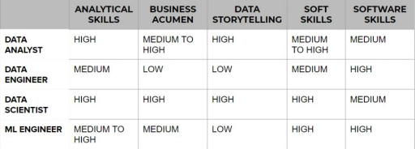 Day 10 - Job Roles Page 46
1. What are Tensors
Thursday, March 25, 2021 4:44 PM
Day 11 - Tensors Page 47
2. 0D Tensor/Scalar
Thursday, March 25, 2021 4:44 PM
Day 11 - Tensors Page 48
3. 1D Tensor/Vector
Thursday, March 25, 2021 4:45 PM
Day 11 - Tensors Page 49
4. 2D Tensor/Matrices
Thursday, March 25, 2021 4:45 PM
Day 11 - Tensors Page 50
5. ND Tensors
Thursday, March 25, 2021 4:45 PM
Day 11 - Tensors Page 51
6. Rank, Axes and Shape
Thursday, March 25, 2021 4:45 PM
Day 11 - Tensors Page 52
7. Example of 1D Tensors
Thursday, March 25, 2021 4:46 PM
Day 11 - Tensors Page 53
8. Example of 2D Tensors
Thursday, March 25, 2021 4:46 PM
Day 11 - Tensors Page 54
9. Example of 3D Tensors
Thursday, March 25, 2021 4:46 PM
Day 11 - Tensors Page 55
10. Example of 4D Tensors
Thursday, March 25, 2021 4:47 PM
Day 11 - Tensors Page 56
12. Example of 5D Tensors
Thursday, March 25, 2021 4:47 PM
Day 11 - Tensors Page 57
1. Installing Anaconda
Friday, March 26, 2021 5:40 PM
Day 12 - Setting up Tools Page 58
2. Jupyter Notebook Intro
Friday, March 26, 2021 5:40 PM
Day 12 - Setting up Tools Page 59
3. Virtual Env
Friday, March 26, 2021 5:40 PM
Day 12 - Setting up Tools Page 60
4. Using Kaggle
Friday, March 26, 2021 5:41 PM
Day 12 - Setting up Tools Page 61
5. Using Google Colab
Friday, March 26, 2021 5:41 PM
Day 12 - Setting up Tools Page 62
6. Running Kaggle Data on Google Colab
Friday, March 26, 2021 5:41 PM
Day 12 - Setting up Tools Page 63
End to End Example
Saturday, March 27, 2021 8:08 AM
Day 13 - End to End Example Page 64
1. Business Problem to ML Problem
Monday, March 29, 2021 7:29 AM
Day 14 - Framing the Problem Page 65
2. Type of Problem
Monday, March 29, 2021 7:30 AM
Day 14 - Framing the Problem Page 66
3. Current Solution
Monday, March 29, 2021 7:30 AM
Day 14 - Framing the Problem Page 67
4. Getting Data
Monday, March 29, 2021 7:30 AM
1. Watch time
2. Search but did not find
3. Content left in the middle
4. Clicked on recommendations(order of recommendations) Day 14 - Framing the Problem Page 68
5. Metrics to measure
Monday, March 29, 2021 7:30 AM
Day 14 - Framing the Problem Page 69
6. Online Vs Batch?
Monday, March 29, 2021 7:31 AM
Day 14 - Framing the Problem Page 70
7. Check Assumptions
Monday, March 29, 2021 7:31 AM
Day 14 - Framing the Problem Page 71
Gathering Data
Tuesday, March 30, 2021 5:35 PM
Day 15 - Working with csv files Page 72
JSON/SQL
Wednesday, March 31, 2021 8:10 AM
Day 16 - Working with JSONSQL Page 73
What is an API
Thursday, April 1, 2021 6:55 AM
Day 17 - API to Pandas DataFrame Page 74
Understanding Your Data
Saturday, April 3, 2021 9:07 AM
Day 19 - Understanding your data with Descriptive Statistics Page 75
Univariate Analysis
Sunday, April 4, 2021 5:39 PM
Day 20 - Univariate Analysis Page 76
Feature Engineering
Thursday, April 8, 2021 6:02 PM
Feature engineering is the process of using domain knowledge to extract features from raw data. These features can be used to improve the performance of machine learning algorithms.
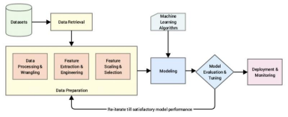
Feature
Engineering
Feature
Transformation_{Feature}
Construction
Missing Value
Imputation
Handling Categorical
Features
Outlier
Detection
Feature
Scaling
Day 23 - Feature Engineering Page 77
Feature Selection
Feature Extraction
1.1 Missing Values Imputation
Thursday, April 8, 2021 7:05 PM
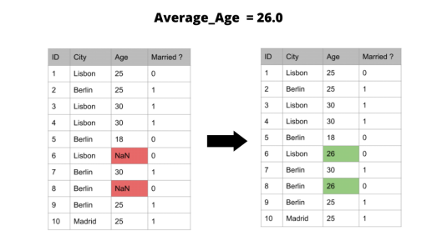 Day 23 - Feature Engineering Page 78
1.2 Handling Categorical Values
Thursday, April 8, 2021 7:06 PM
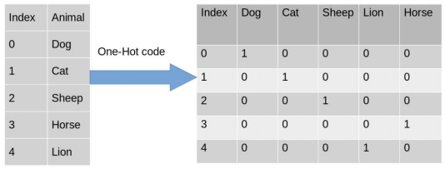 Day 23 - Feature Engineering Page 79
1.3 Outlier Detection
Thursday, April 8, 2021 7:07 PM
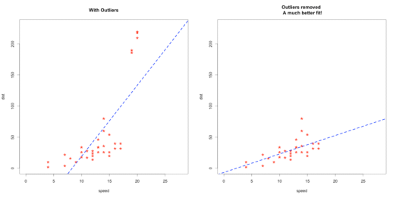 Day 23 - Feature Engineering Page 80

